**SETUP ENVIROMENT**

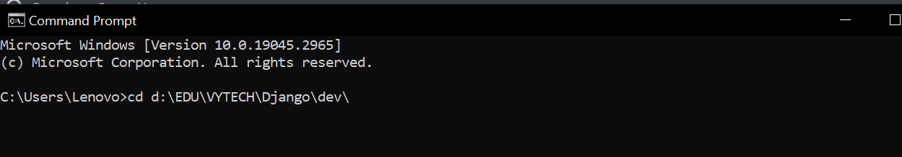

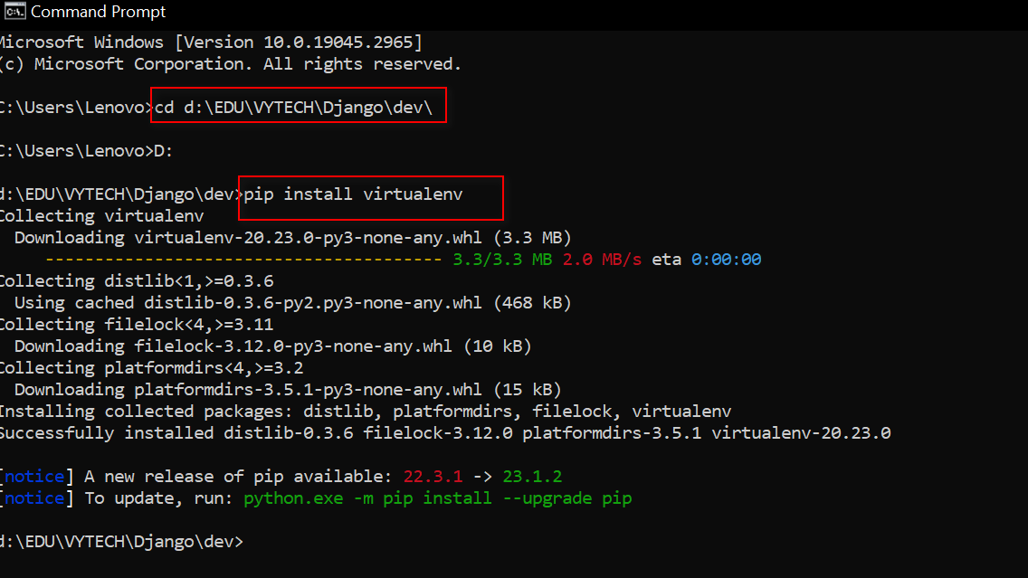

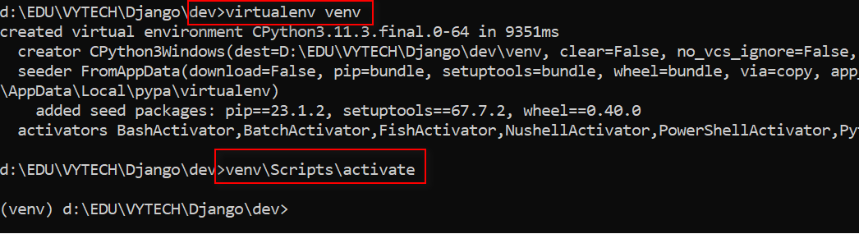

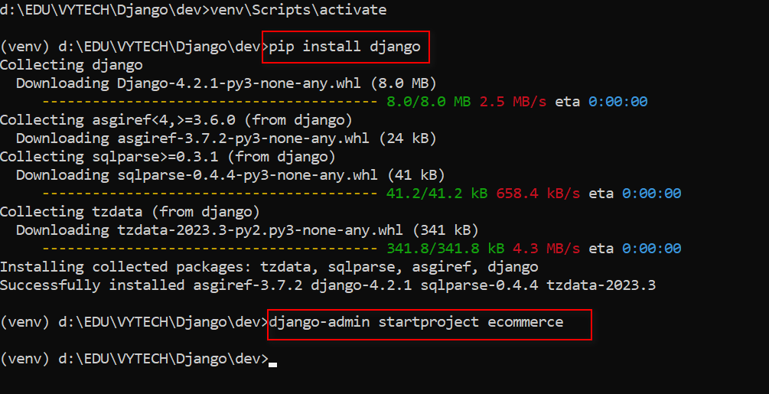

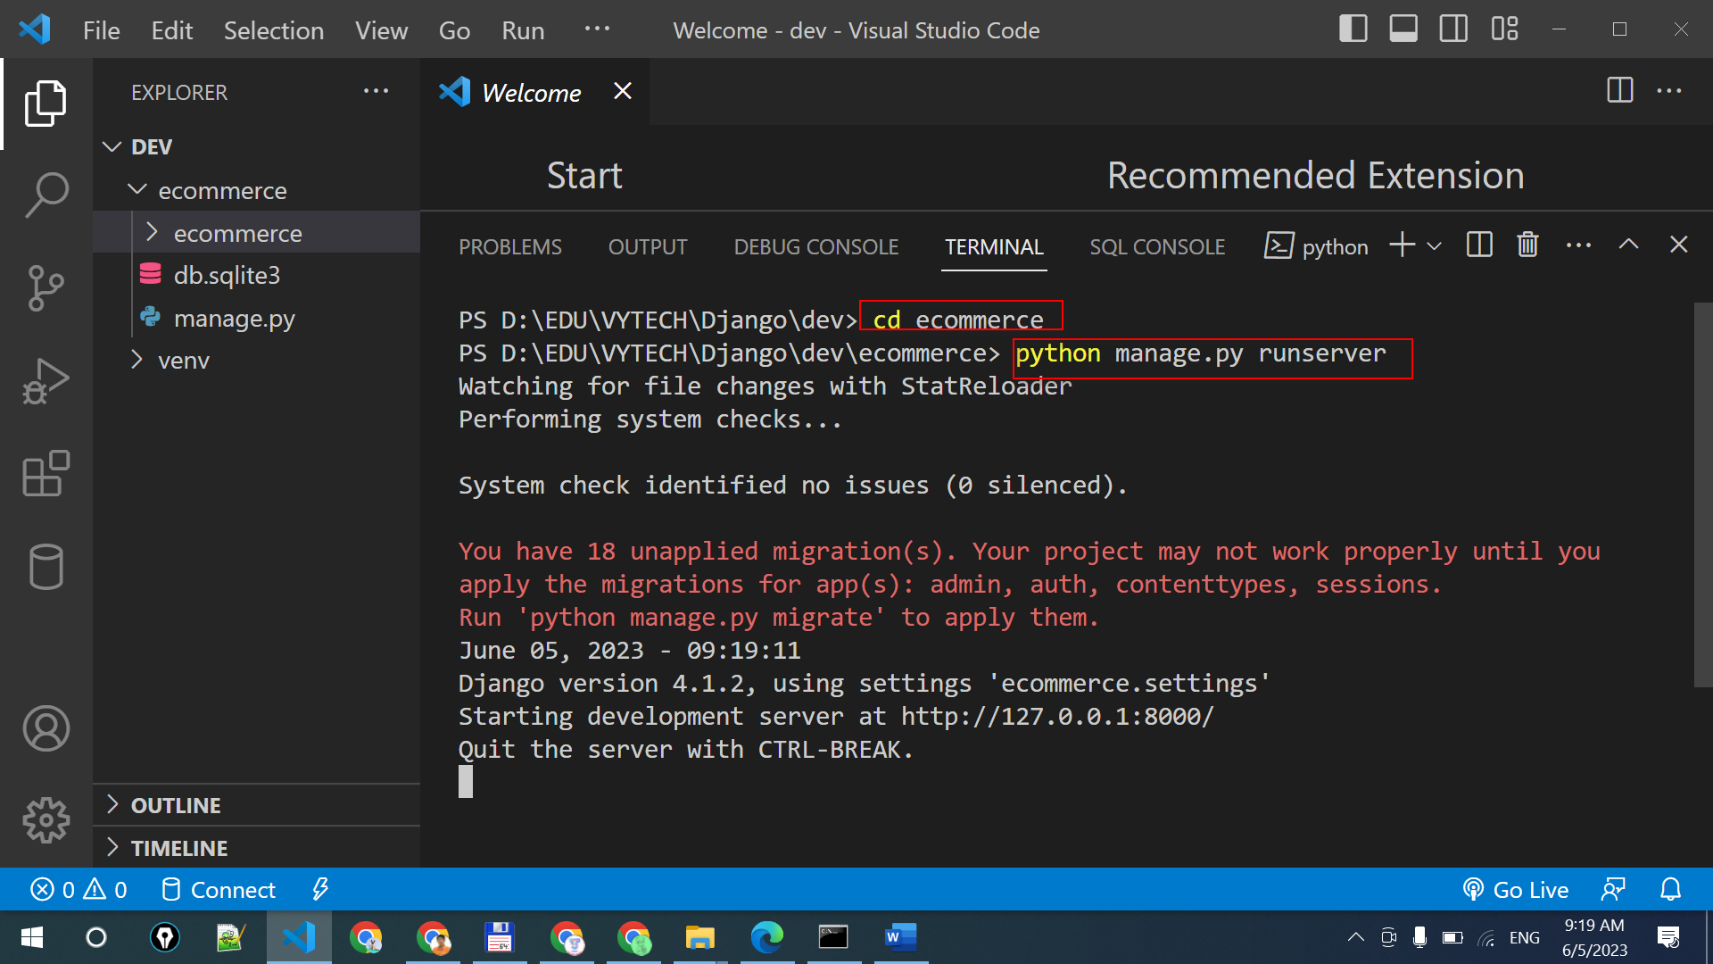

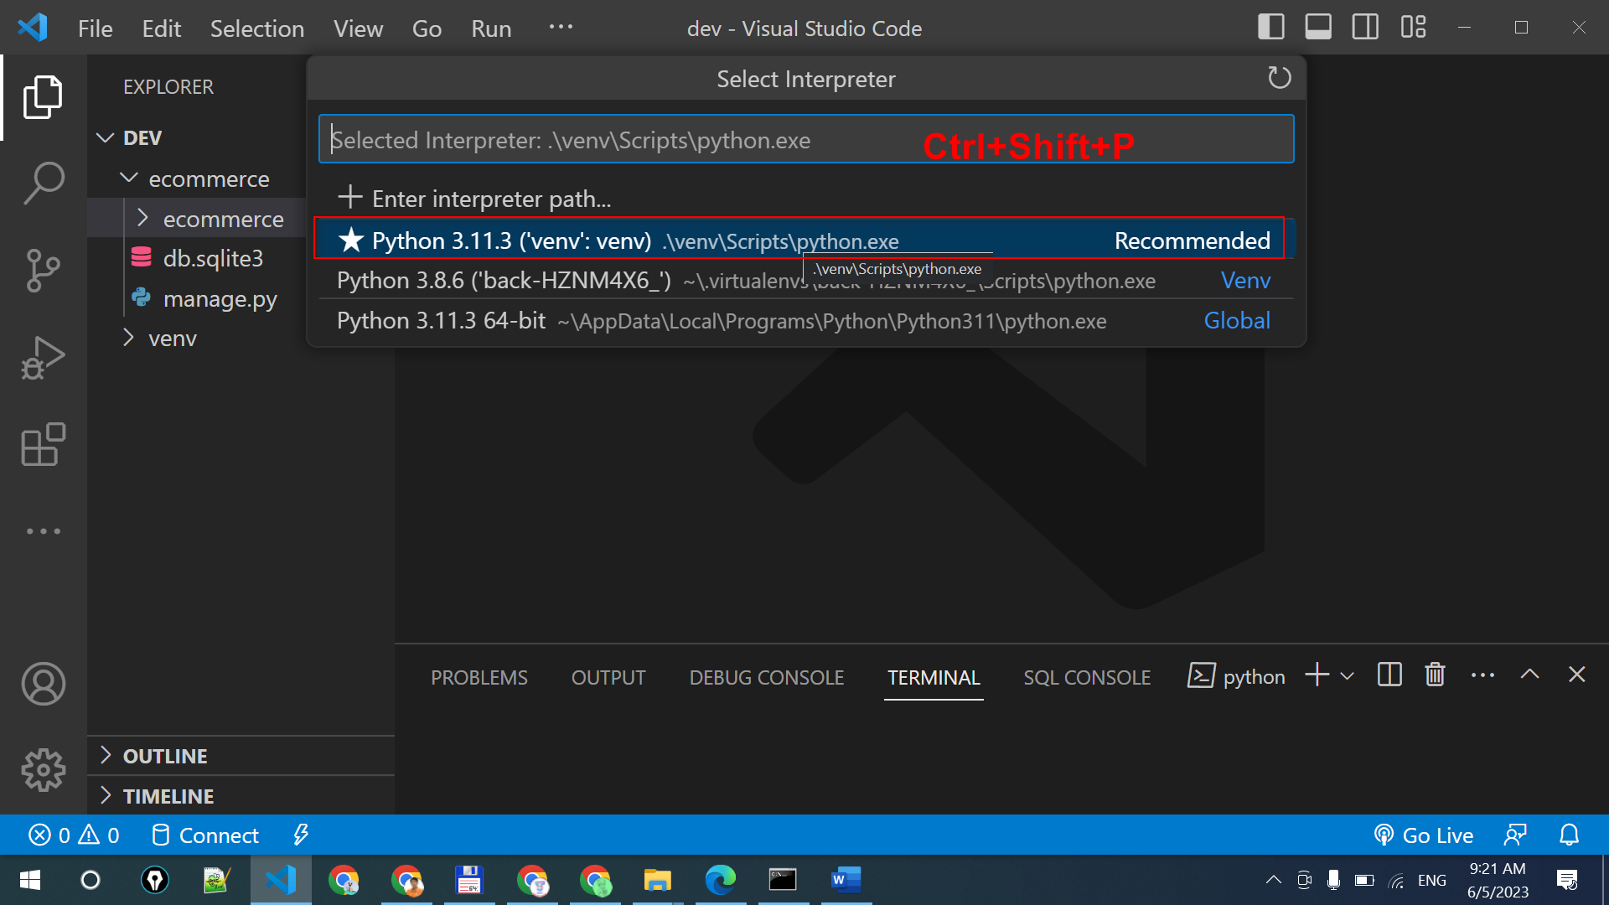

**BUILDING OUR MODEL**

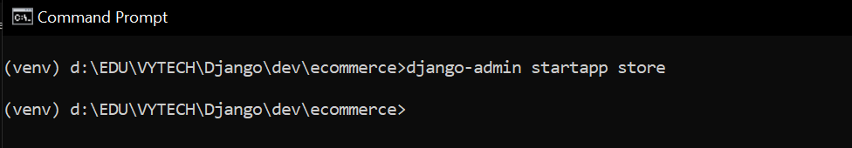

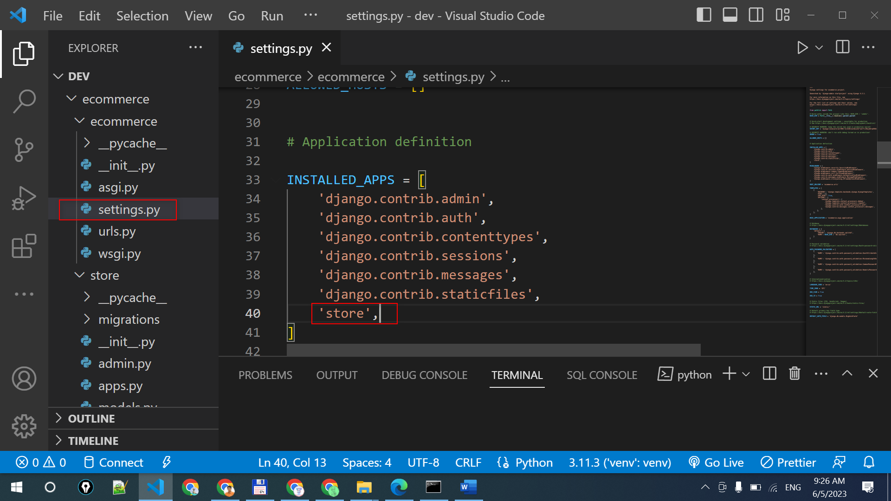

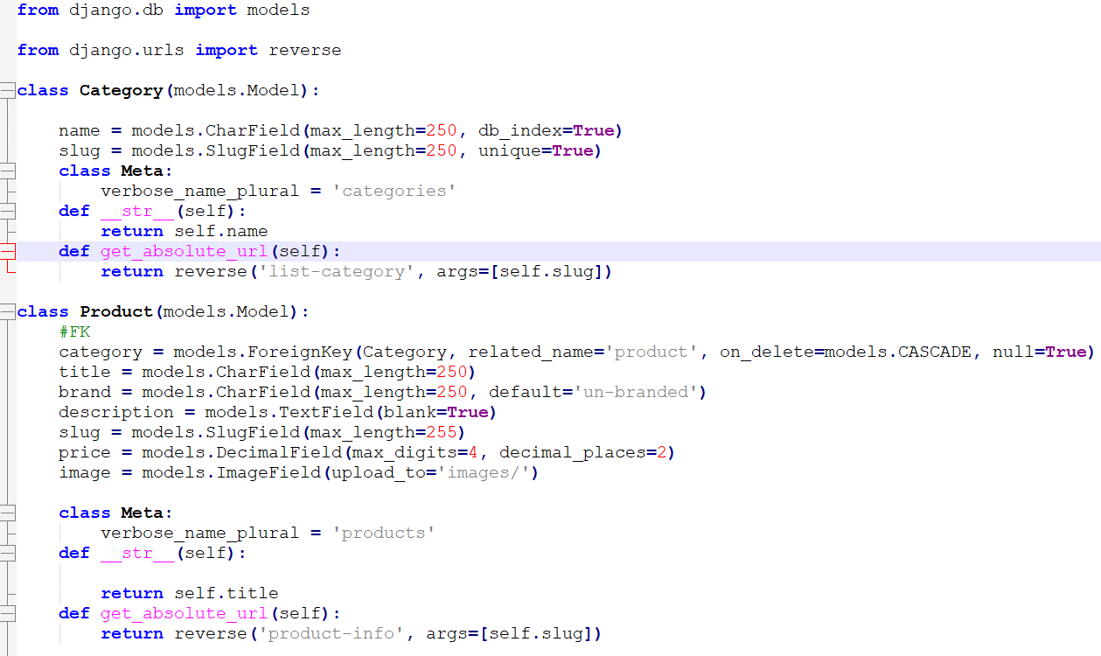

from django.db import models

from django.urls import reverse

class Category(models.Model):

name = models.CharField(max_length=250, db_index=True)

slug = models.SlugField(max_length=250, unique=True)

class Meta:

verbose_name_plural = 'categories'

def __str__(self):

return self.name

def get_absolute_url(self):

return reverse('list-category', args=[self.slug])

class Product(models.Model):

#FK

category = models.ForeignKey(Category, related_name='product', on_delete=models.CASCADE, null=True)

title = models.CharField(max_length=250)

brand = models.CharField(max_length=250, default='un-branded')

description = models.TextField(blank=True)

slug = models.SlugField(max_length=255)

price = models.DecimalField(max_digits=4, decimal_places=2)

image = models.ImageField(upload_to='images/')

class Meta:

verbose_name_plural = 'products'

def __str__(self):

return self.title

def get_absolute_url(self):

return reverse('product-info', args=[self.slug])

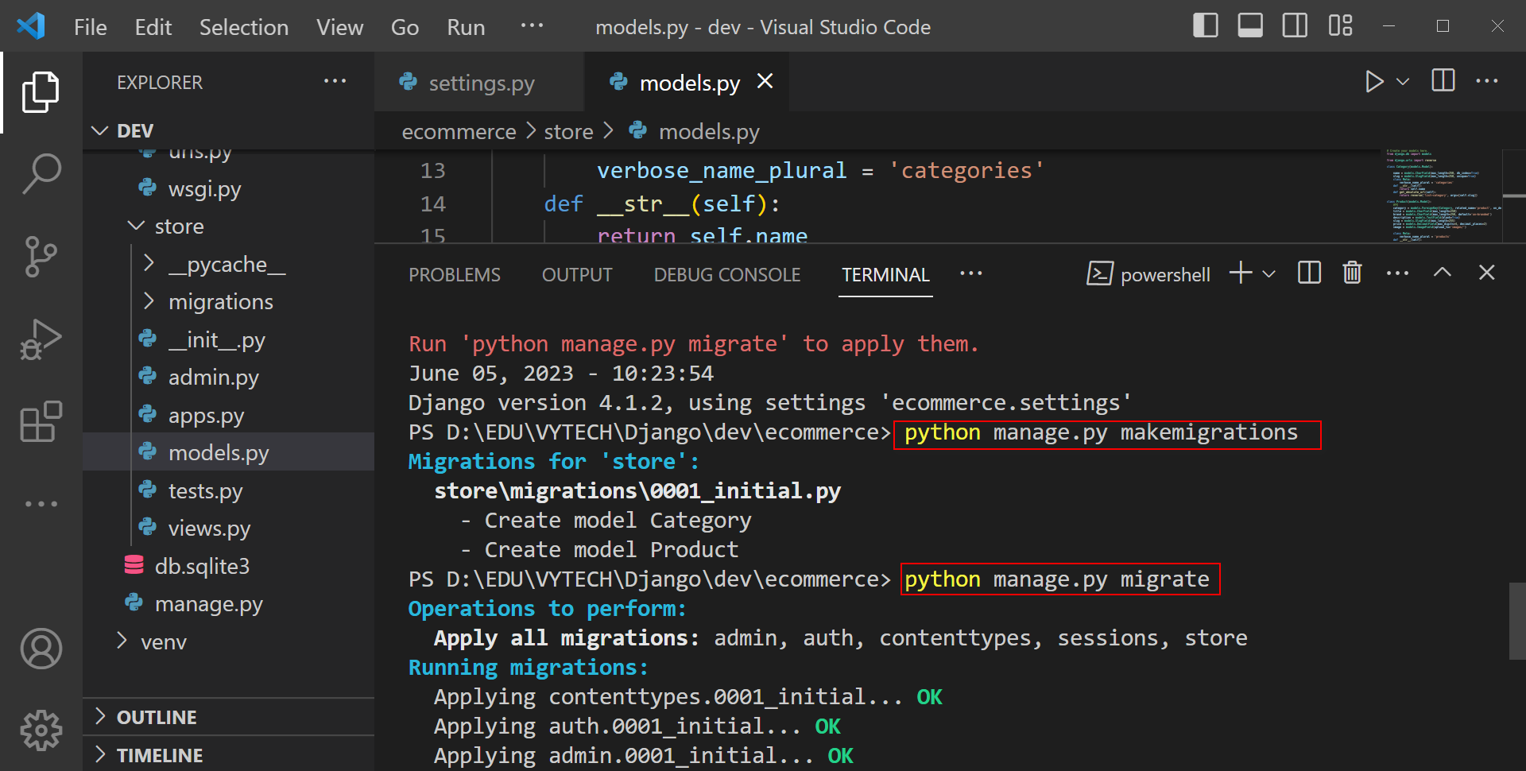

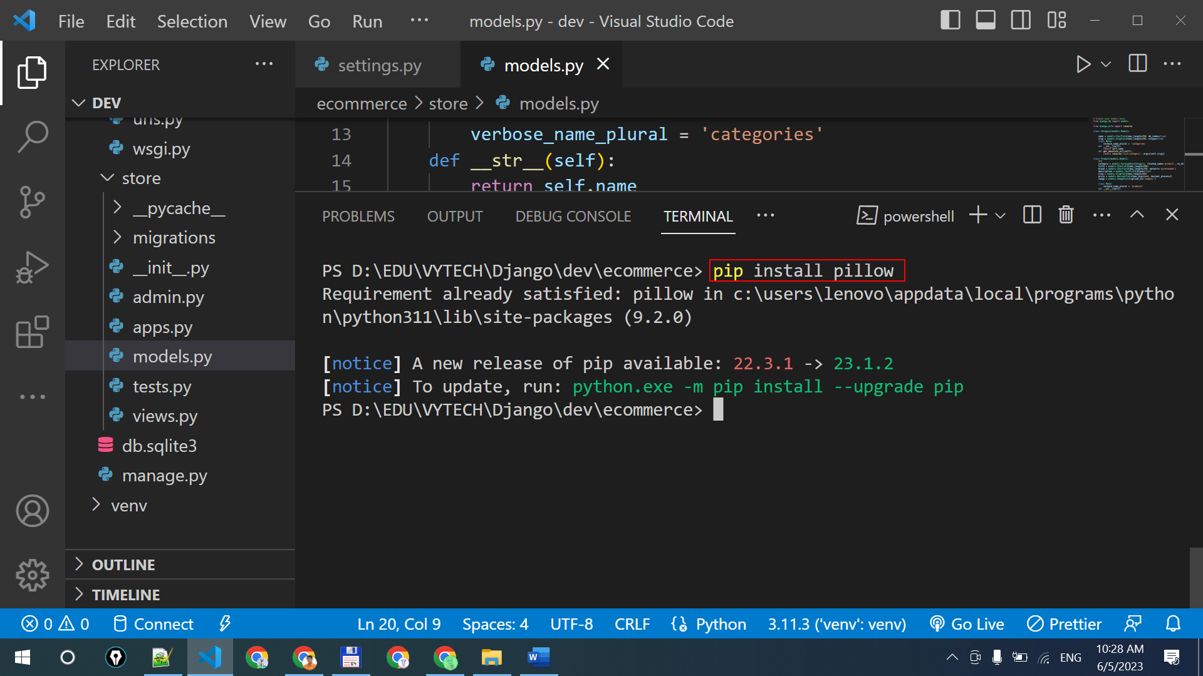

**CONFIGURATION DJANGO FOR STATIC FILES**

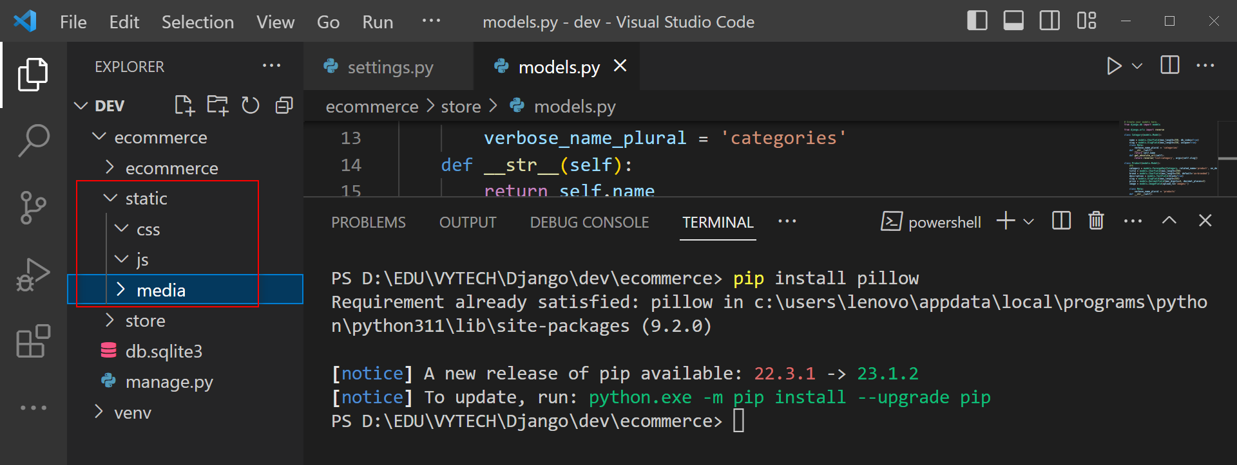

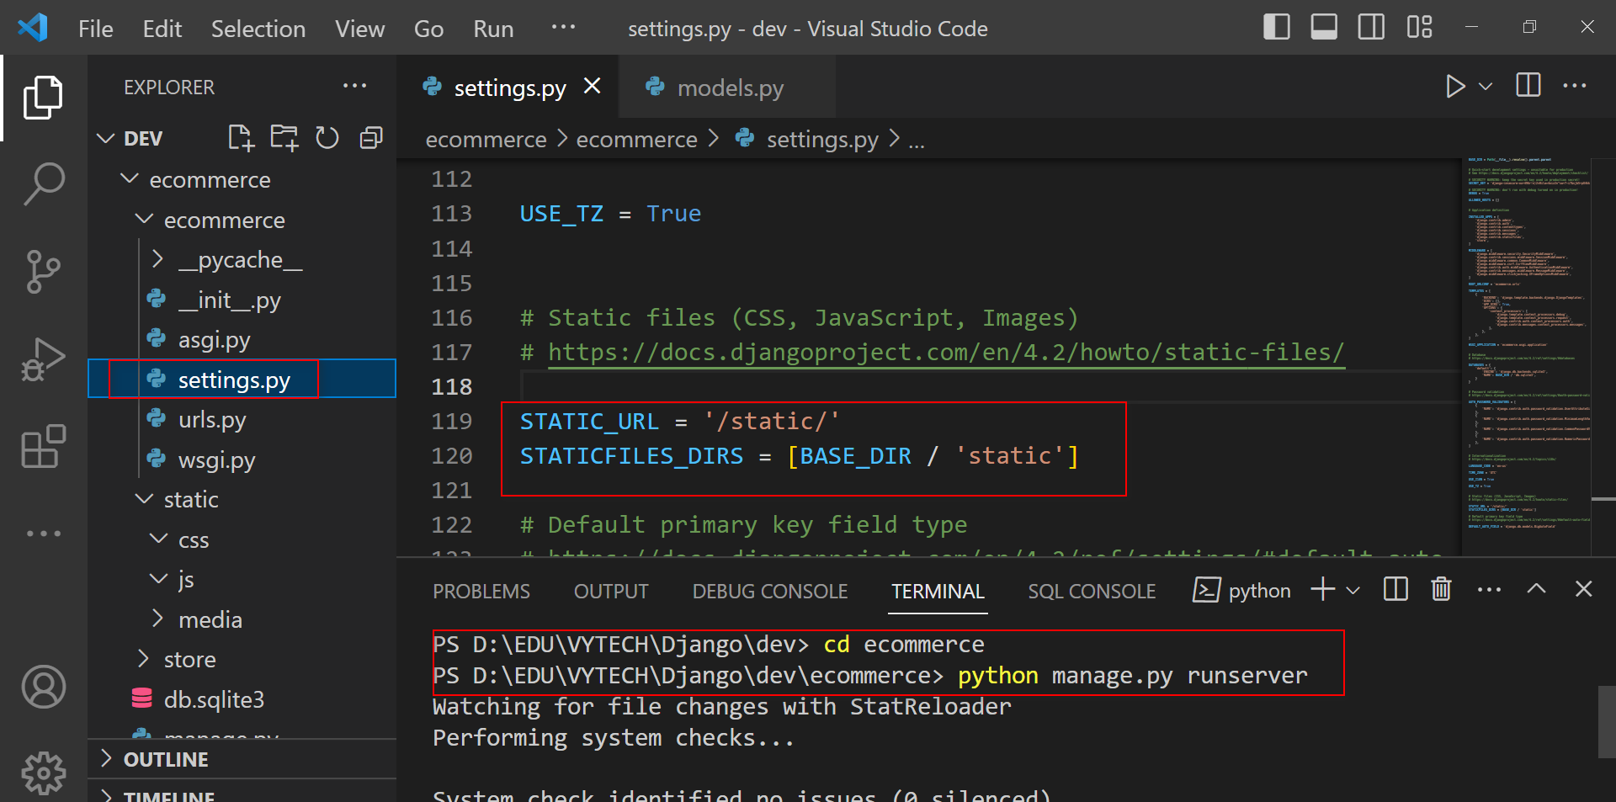

**CONFIGURING DJANGO FOR IMAGES UPLOAD**

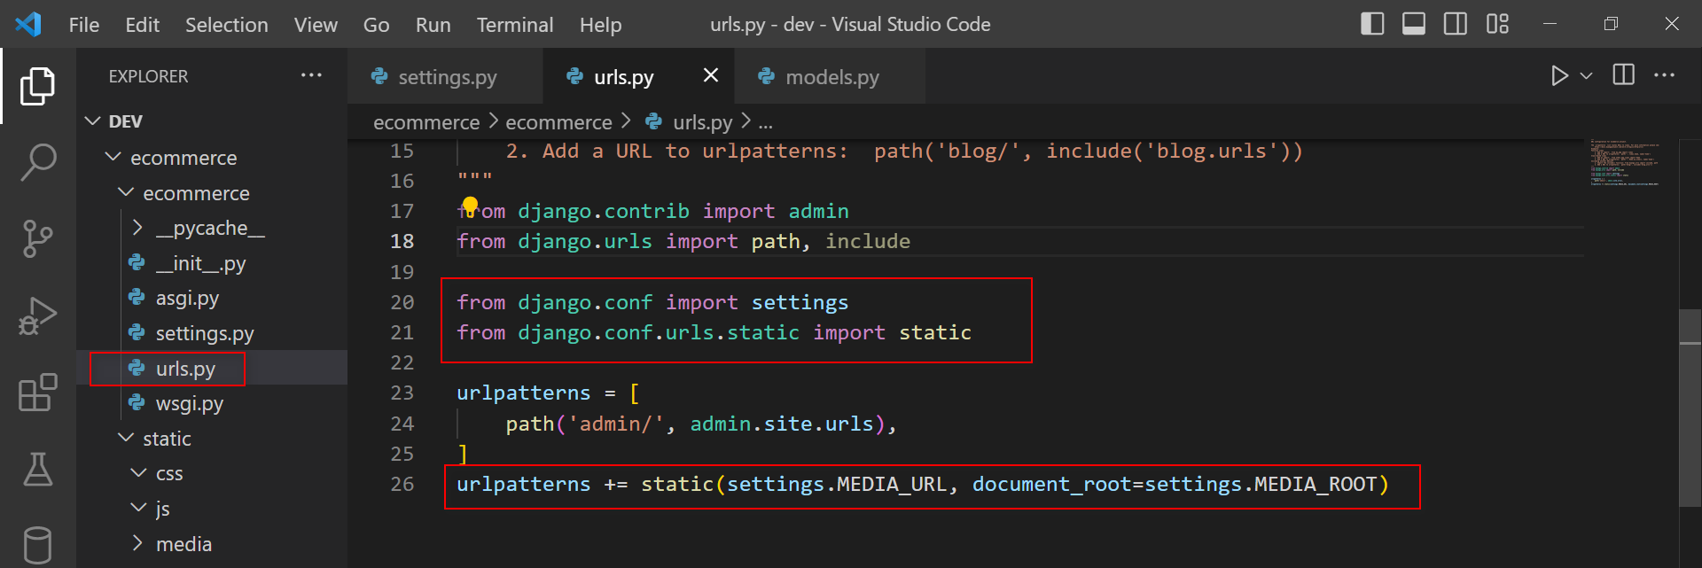

**BASIC DJANGO ADMIN CONFIGURATION**

# Register your models here.

from . models import Category, Product

@admin.register(Category)

class CategoryAdmin(admin.ModelAdmin):

    prepopulated_fields = {'slug': ('name',)}

@admin.register(Product)

class ProductAdmin(admin.ModelAdmin):

    prepopulated_fields = {'slug': ('title',)}

**CREATE SUPER USER**

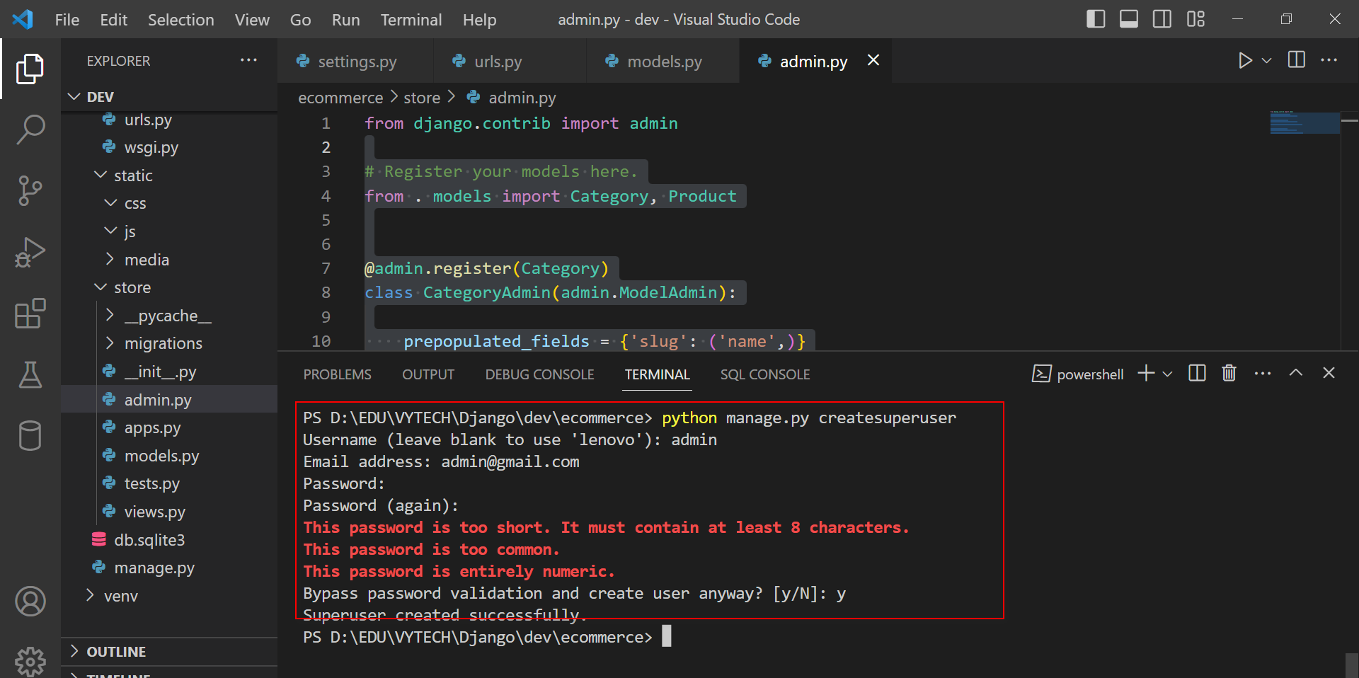

**CONFIGURE TEMPLATE RENDERING**

**Create file html**

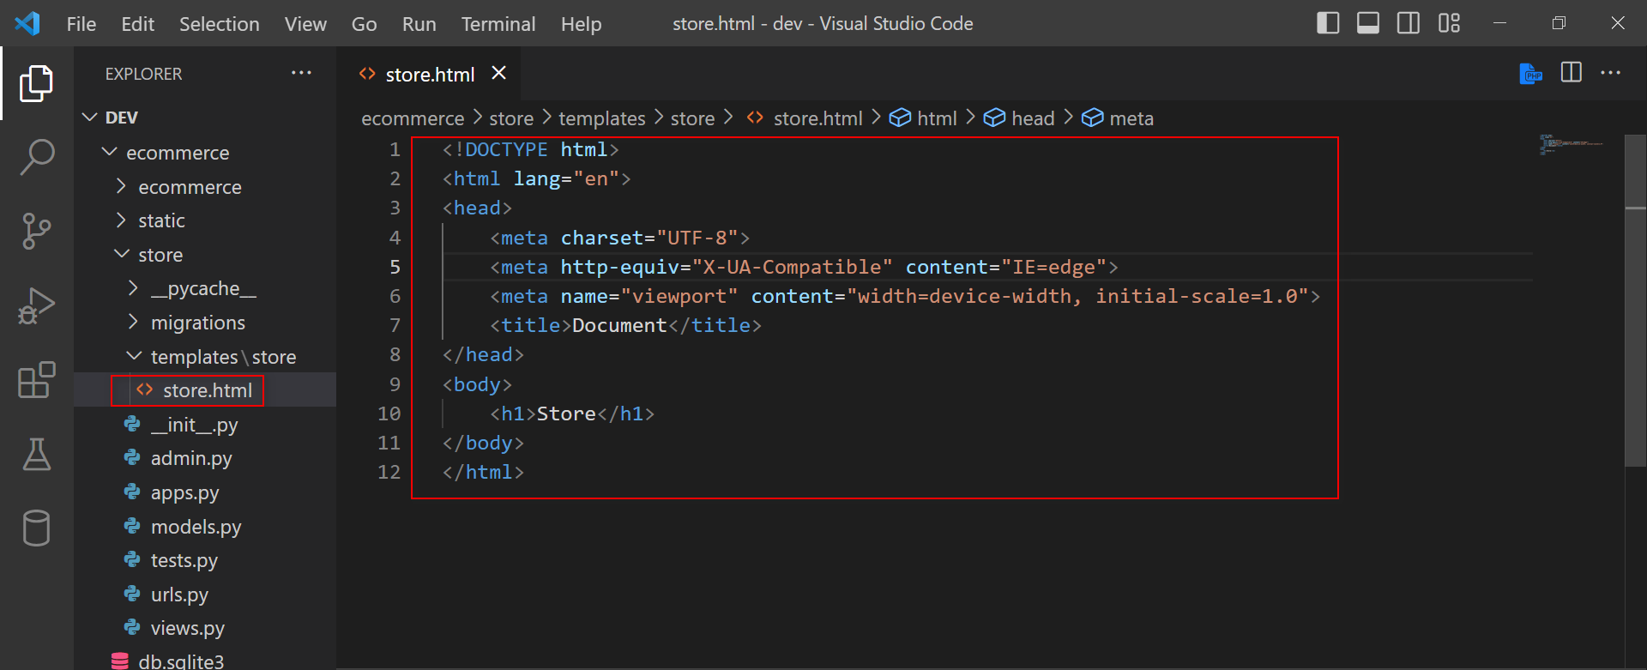

**Create content for file views.py**

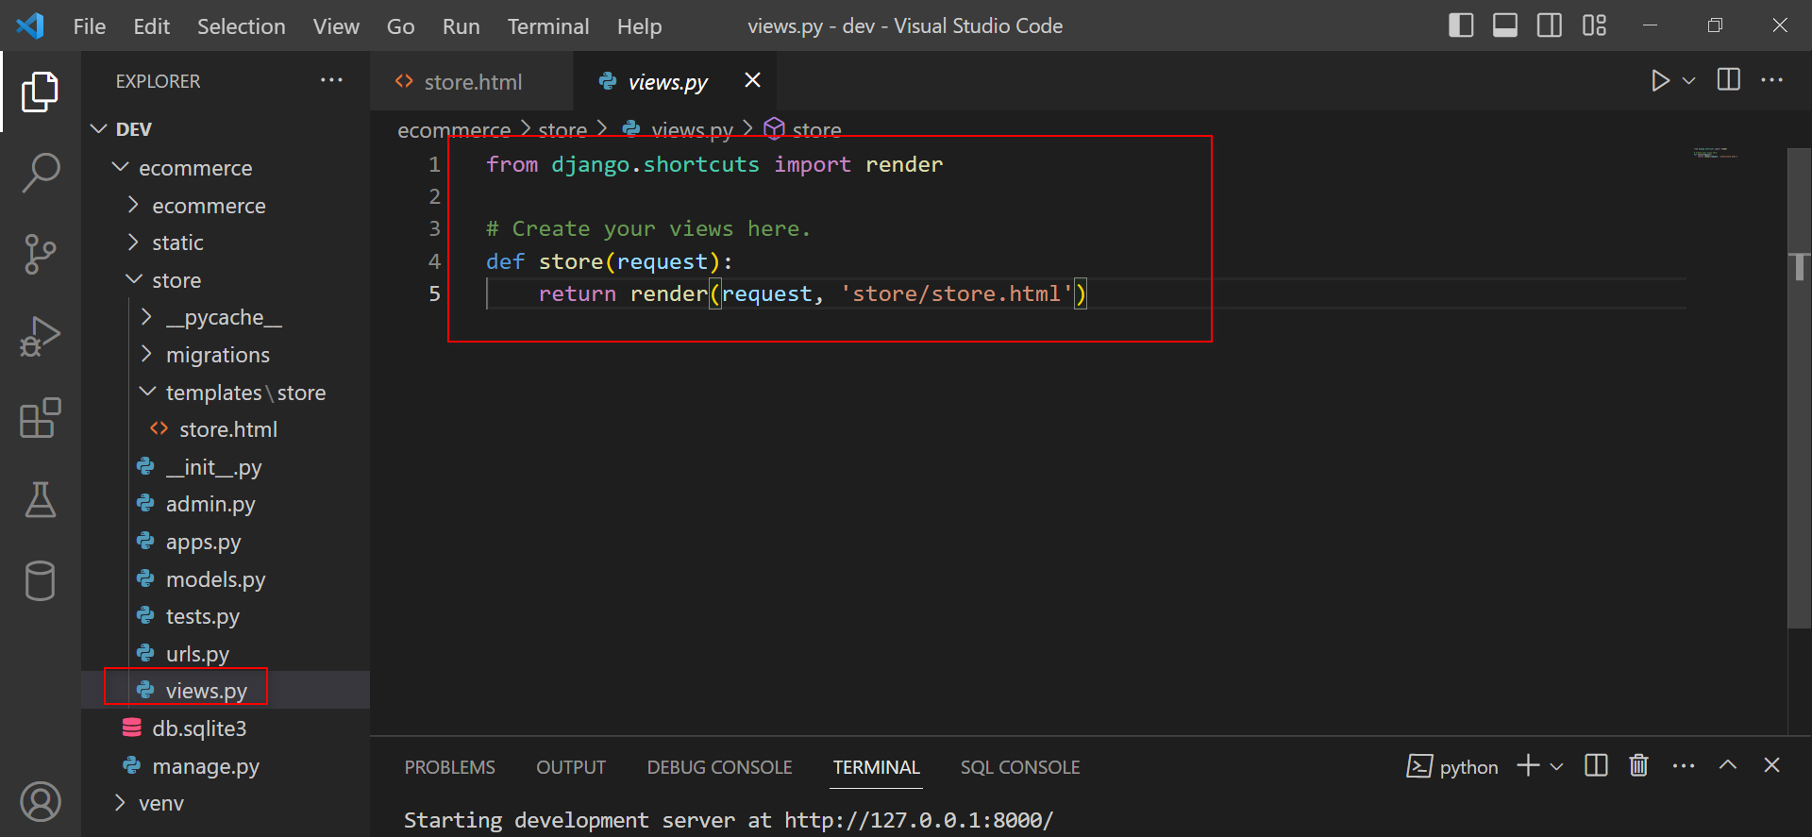

**Create file urls.py and write content**

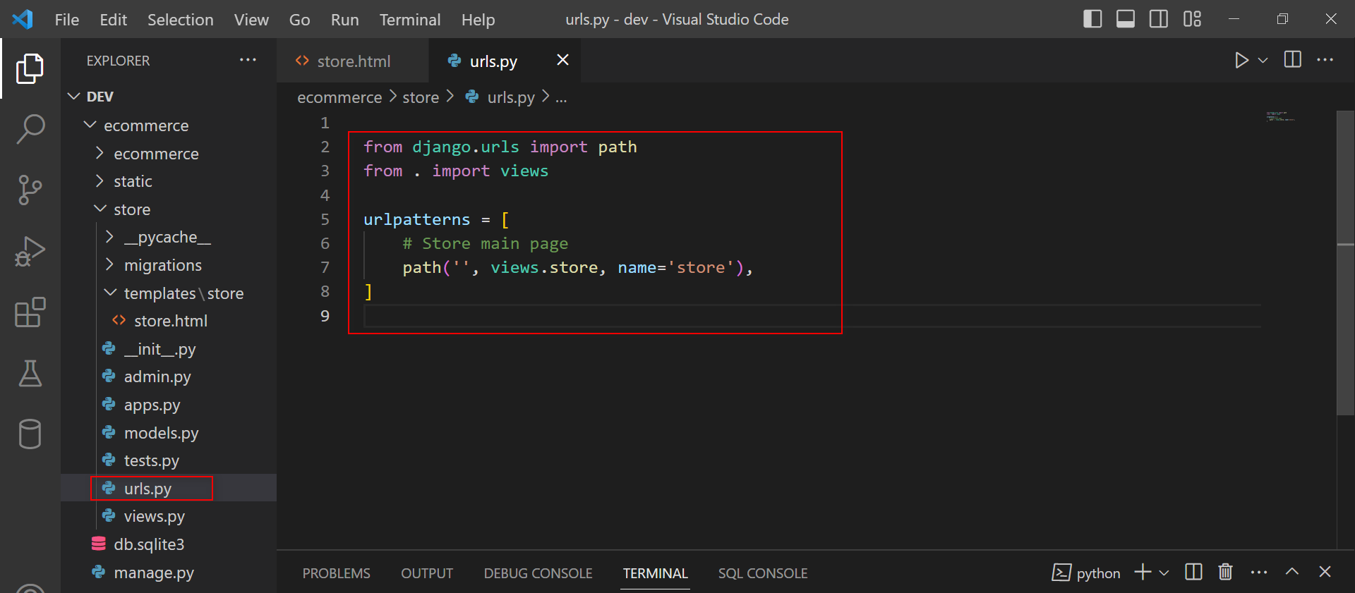

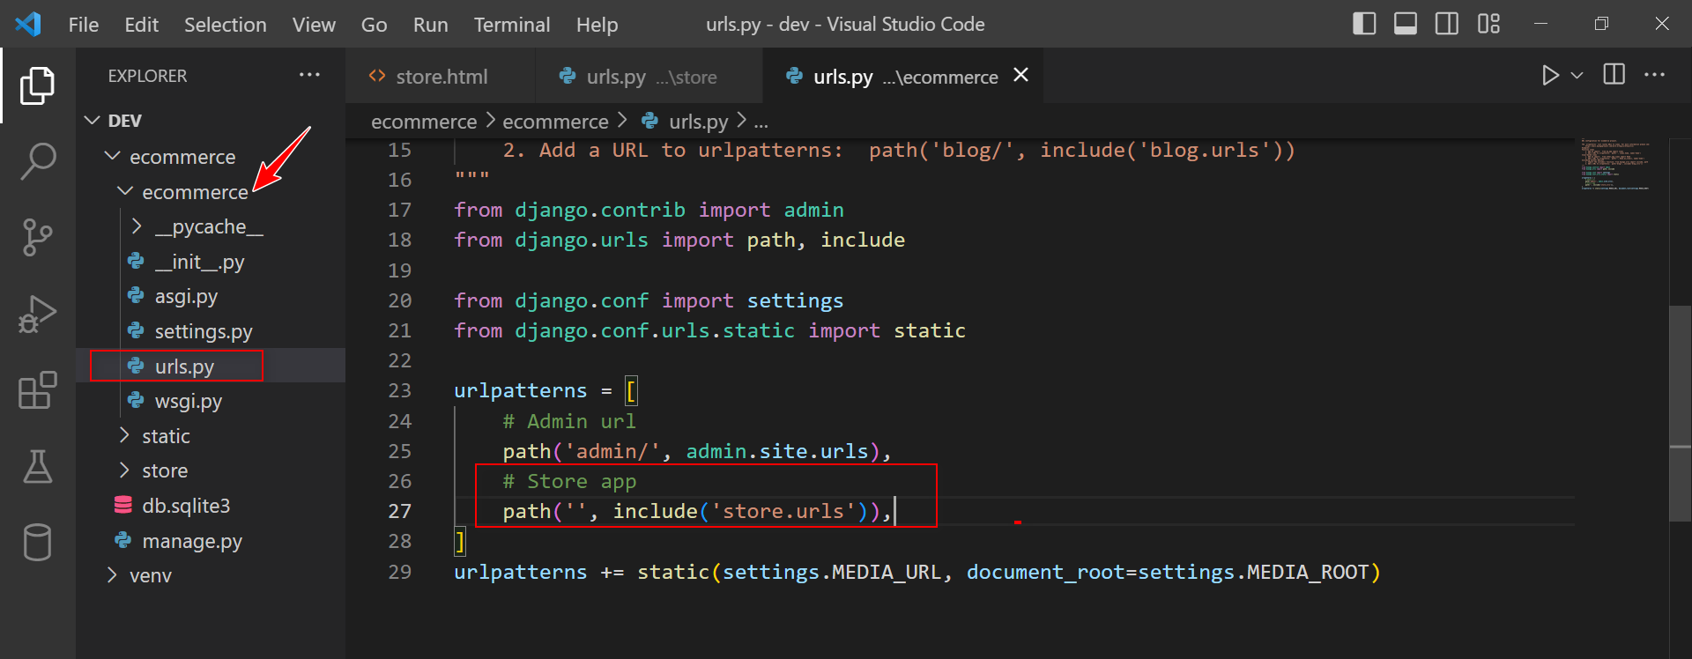

**CREATE BASE PAGES AND STORE PAGES**

**Base pages (Extract file Base.html)**

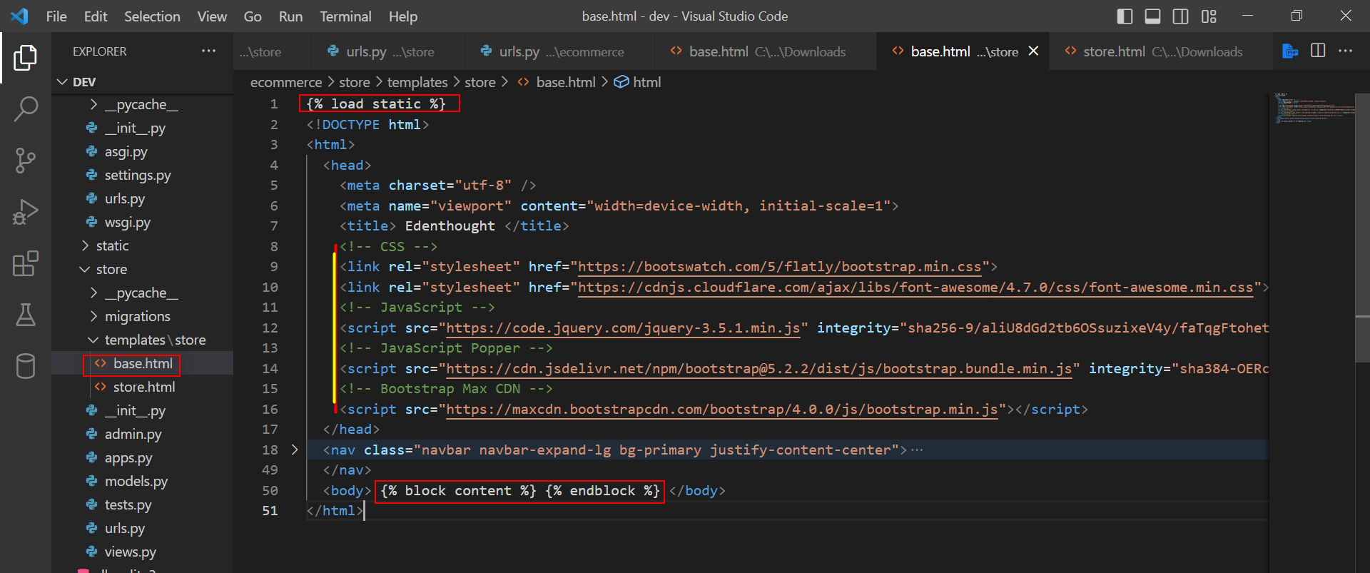

**Store pages (Extract file store.html)**

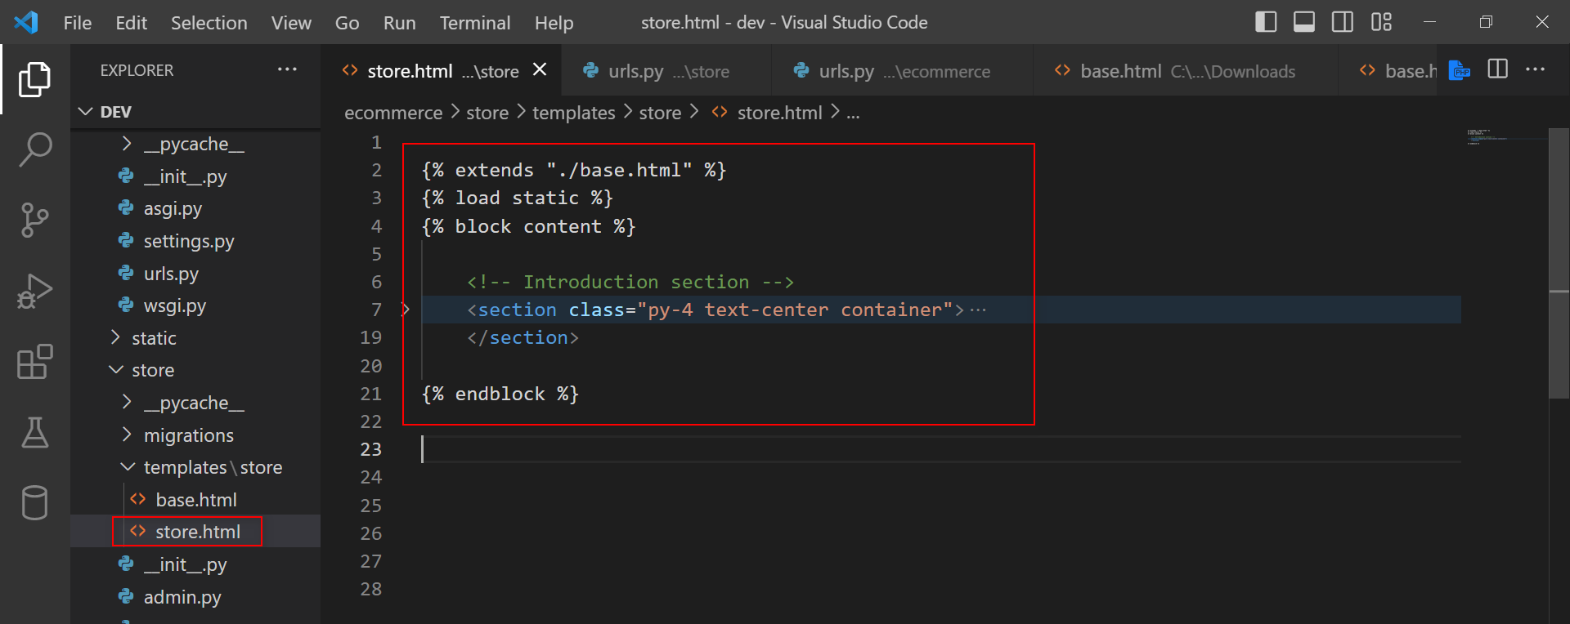

**Building the category view**

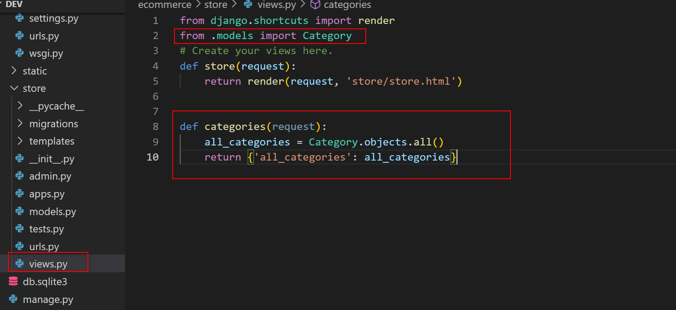

**Update temlates for categories use in base file, all pages**

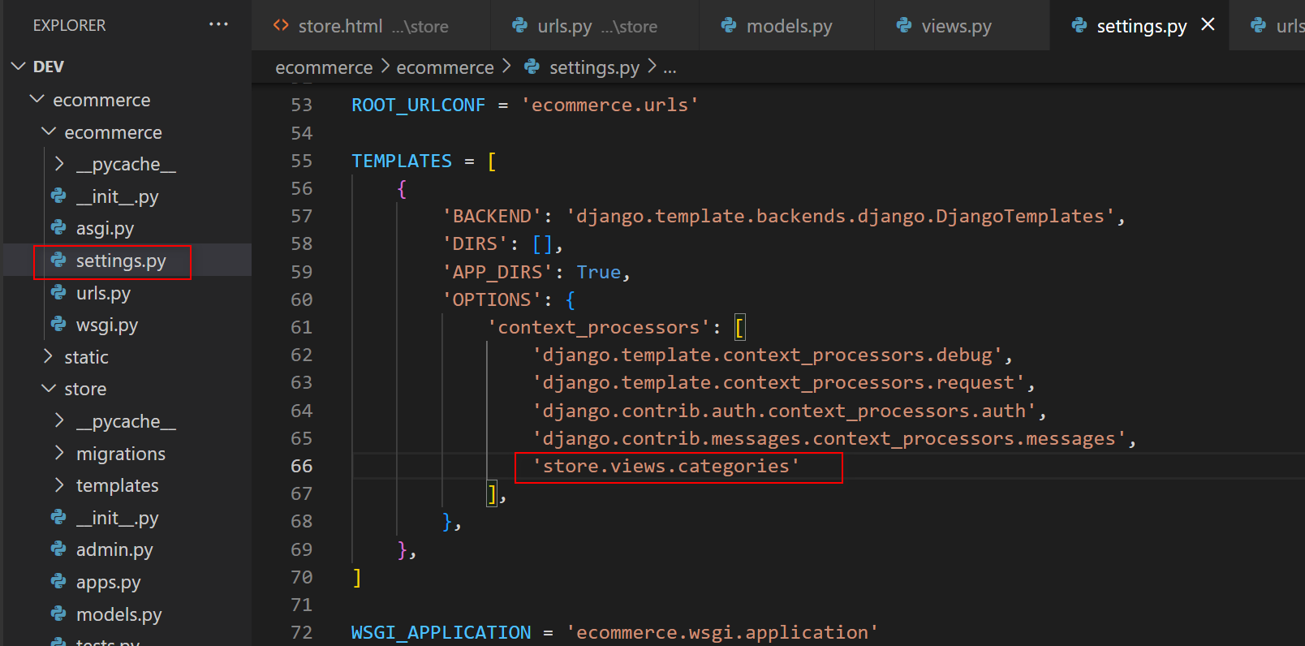

**Building the categoris views**

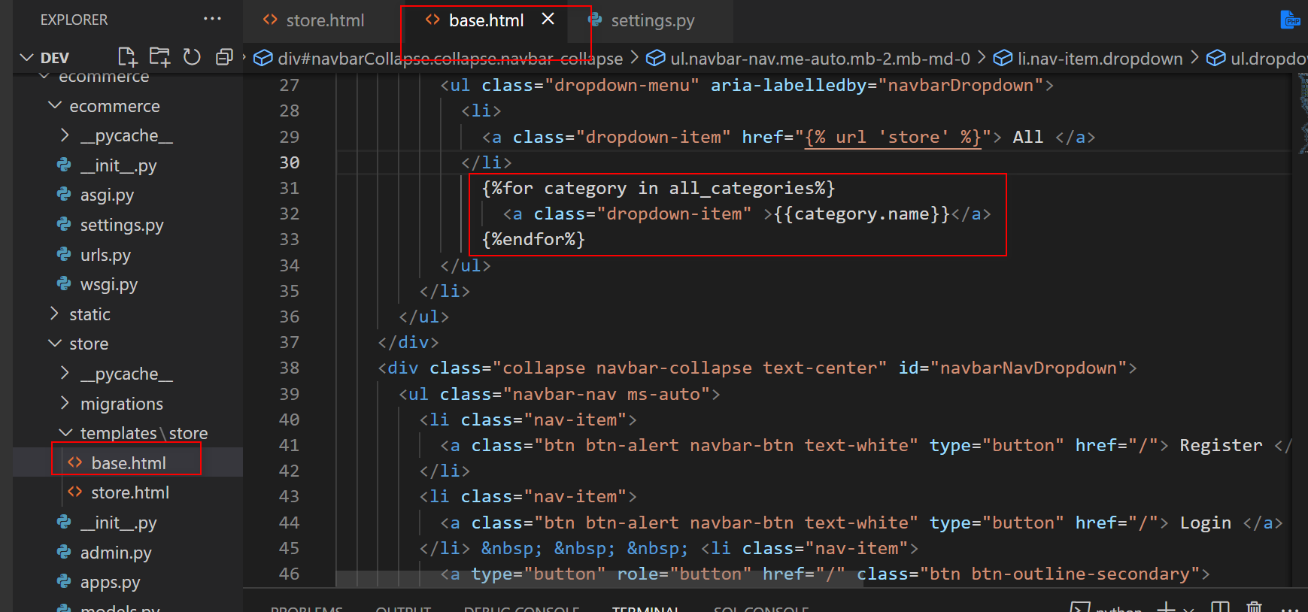

**Styling main product data grid**

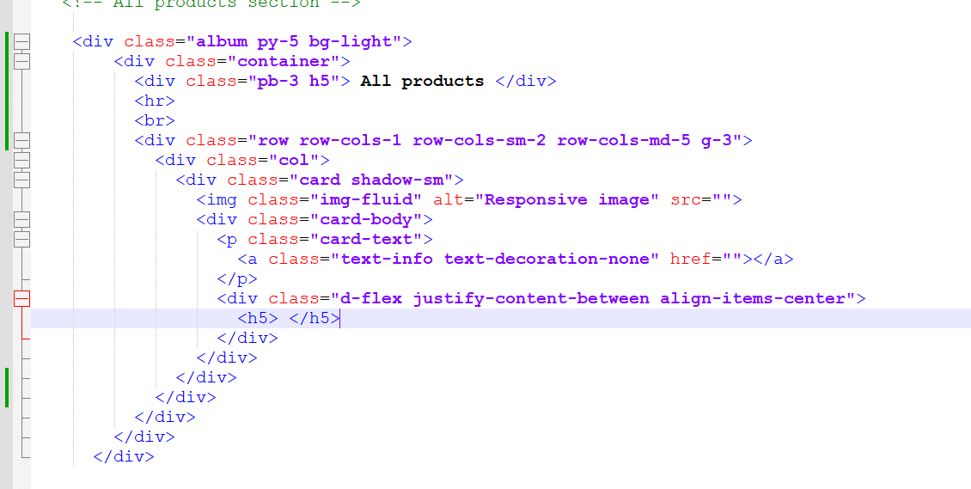

**Buil main product**

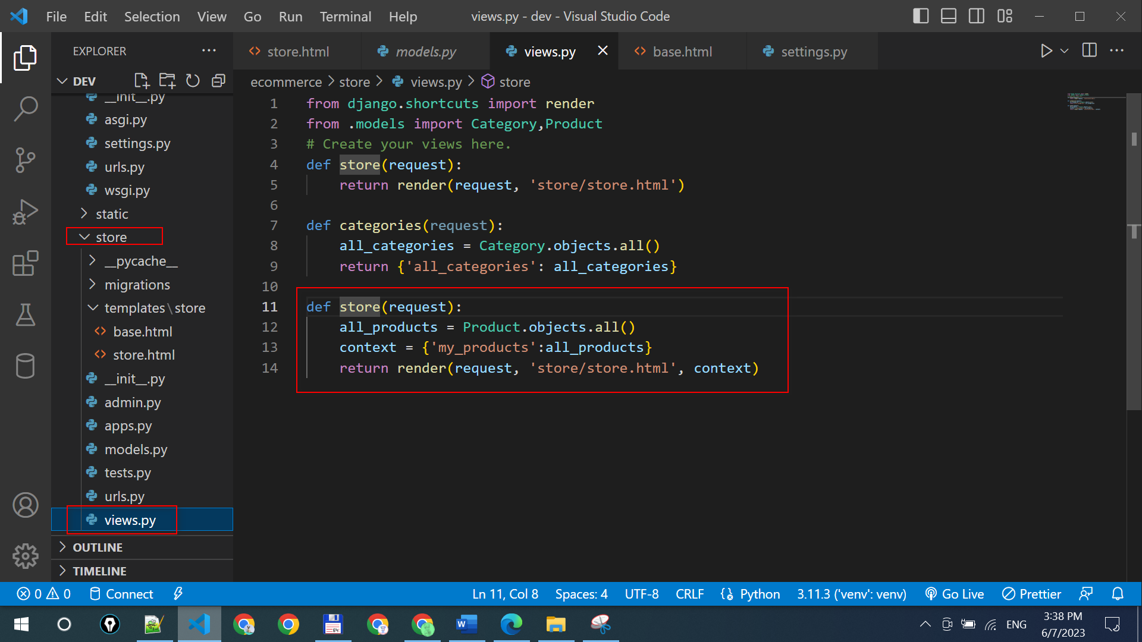

**Fill data to HTML**

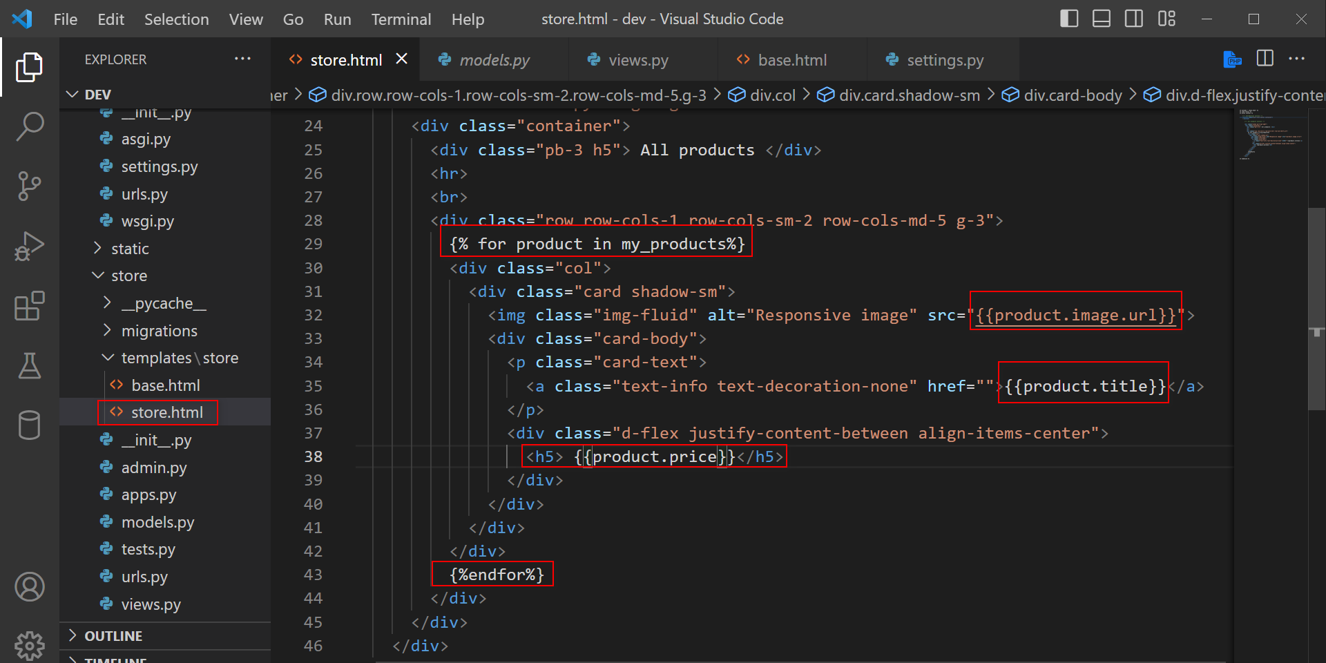

**Create link for product detail**

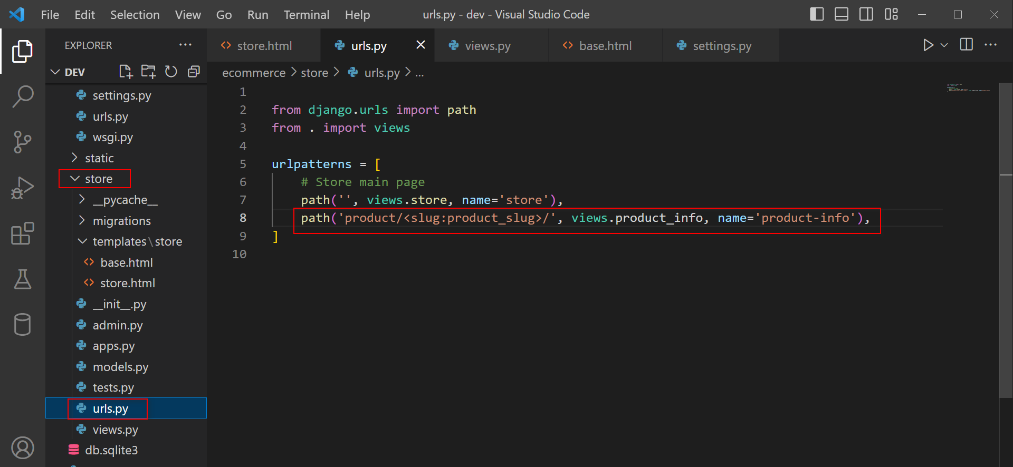

**Function load data to product info**

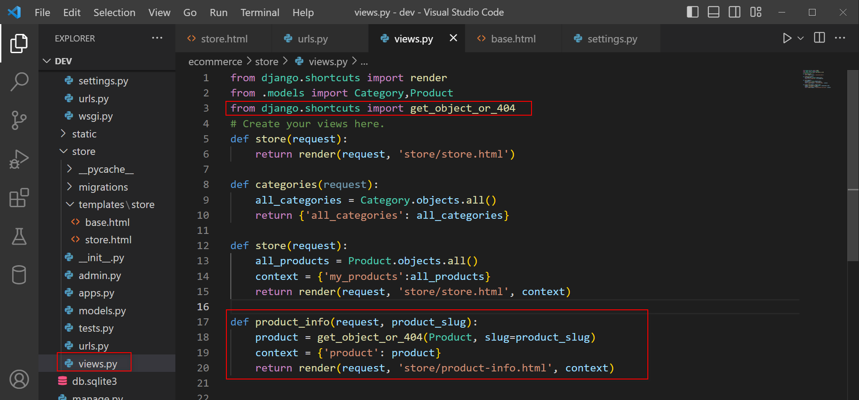

**Set position to data display**

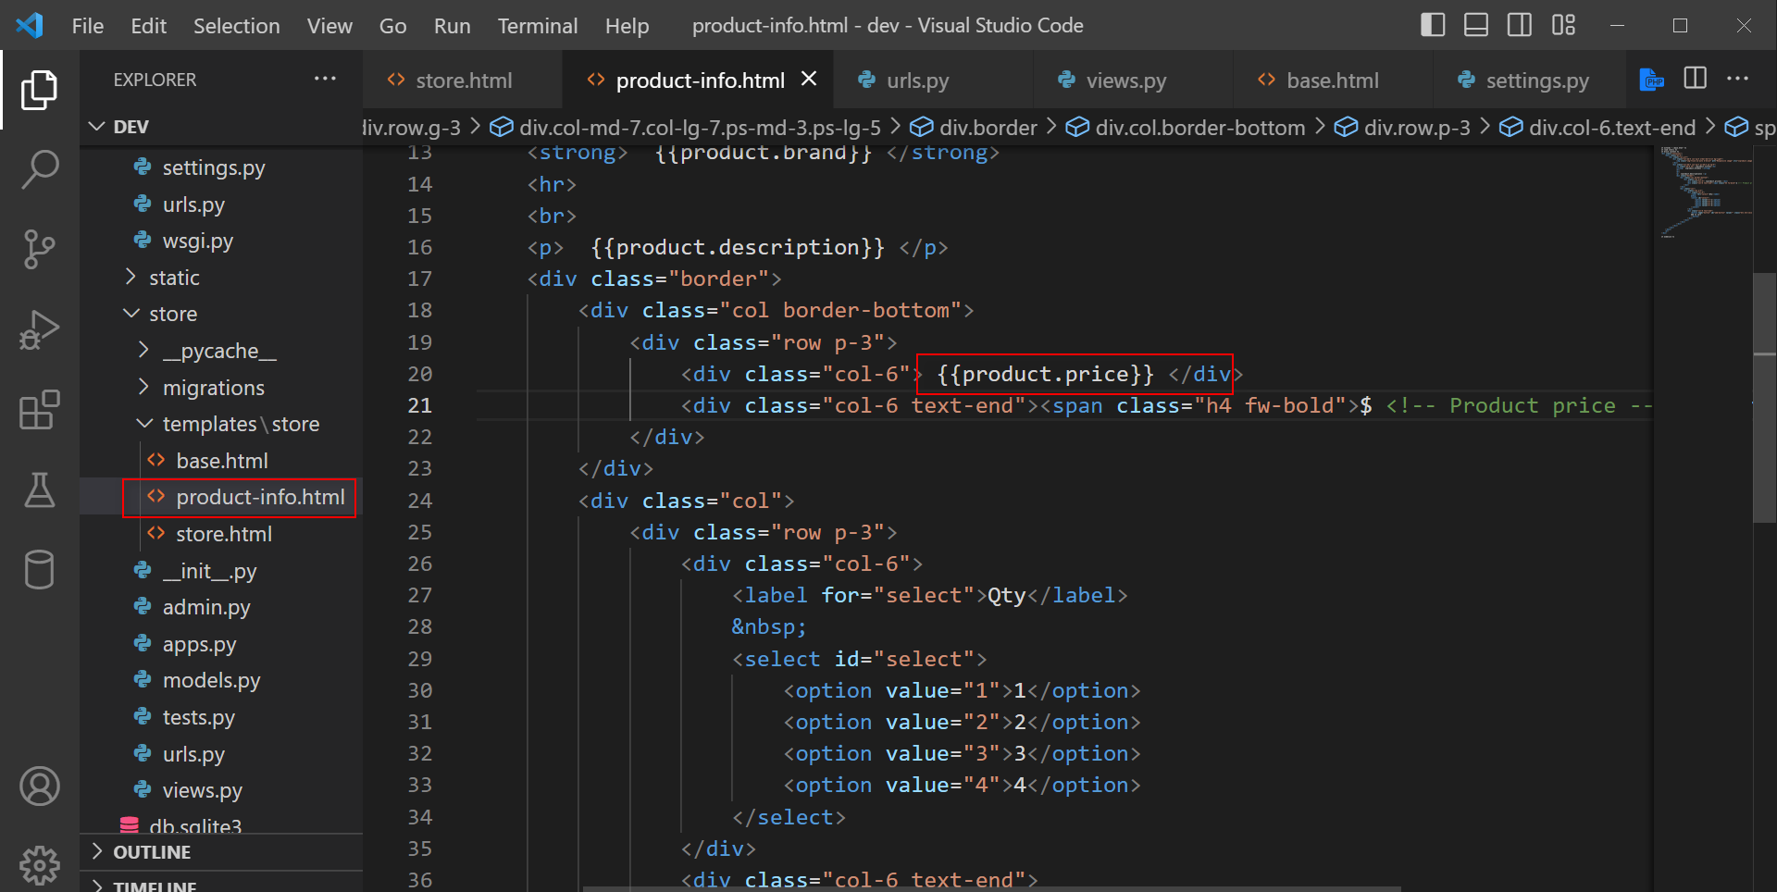

**Creating dynamic links**

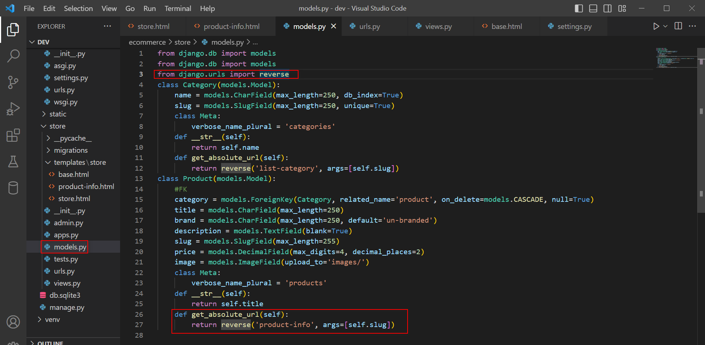

**Create absolute link**

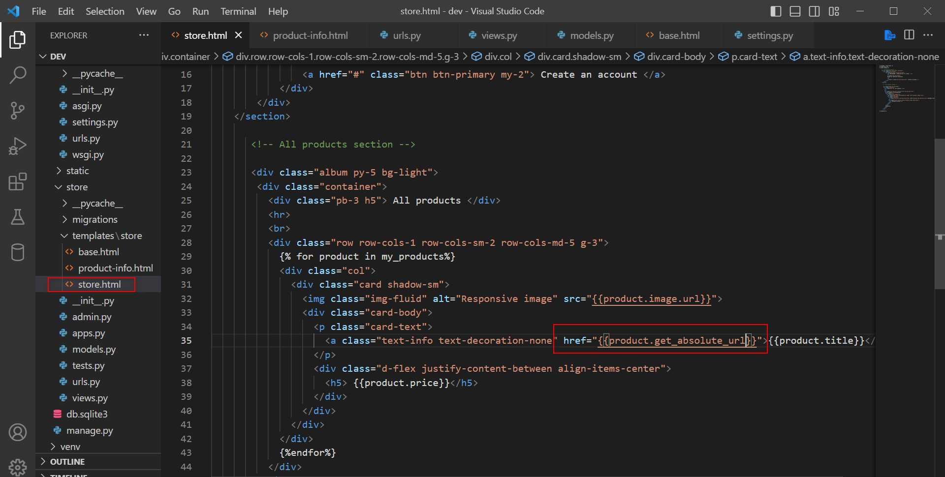

**Building the product category data grid**

1. **Urls of store**

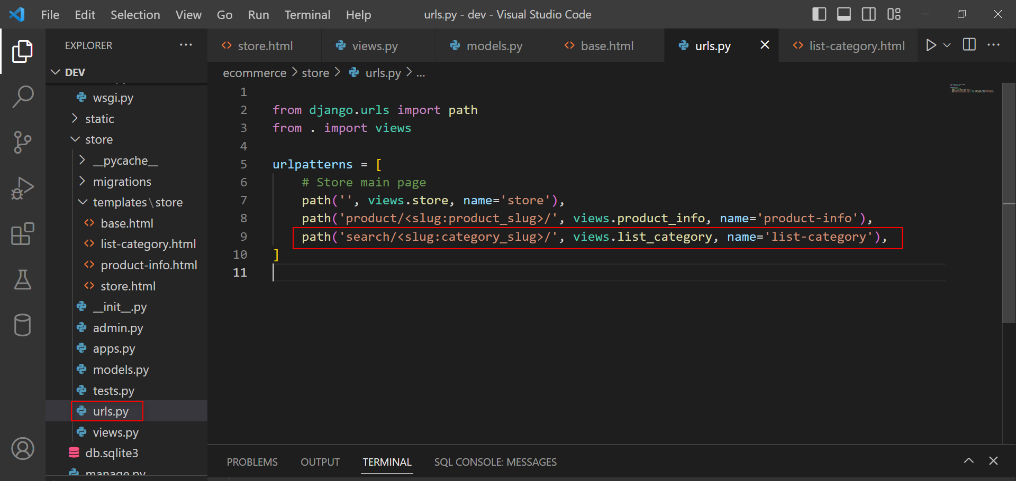

**View of store**

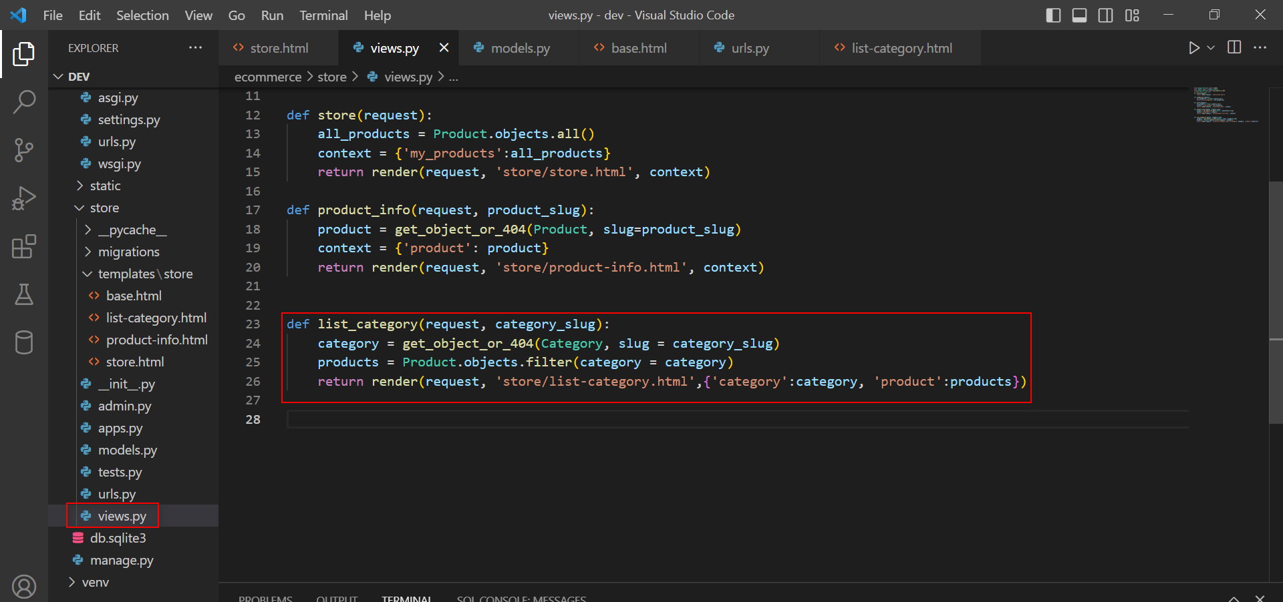

**Base**

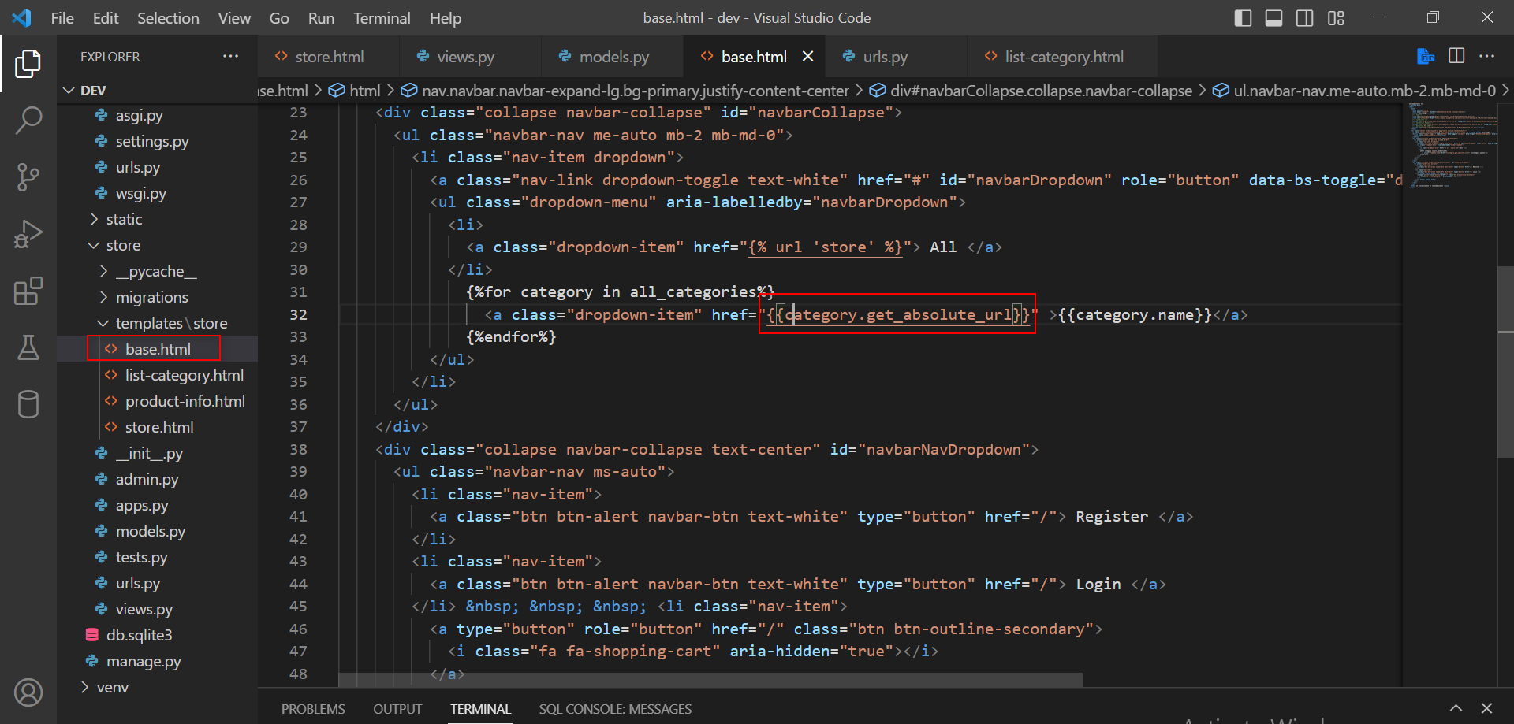

**Add list-category.html**

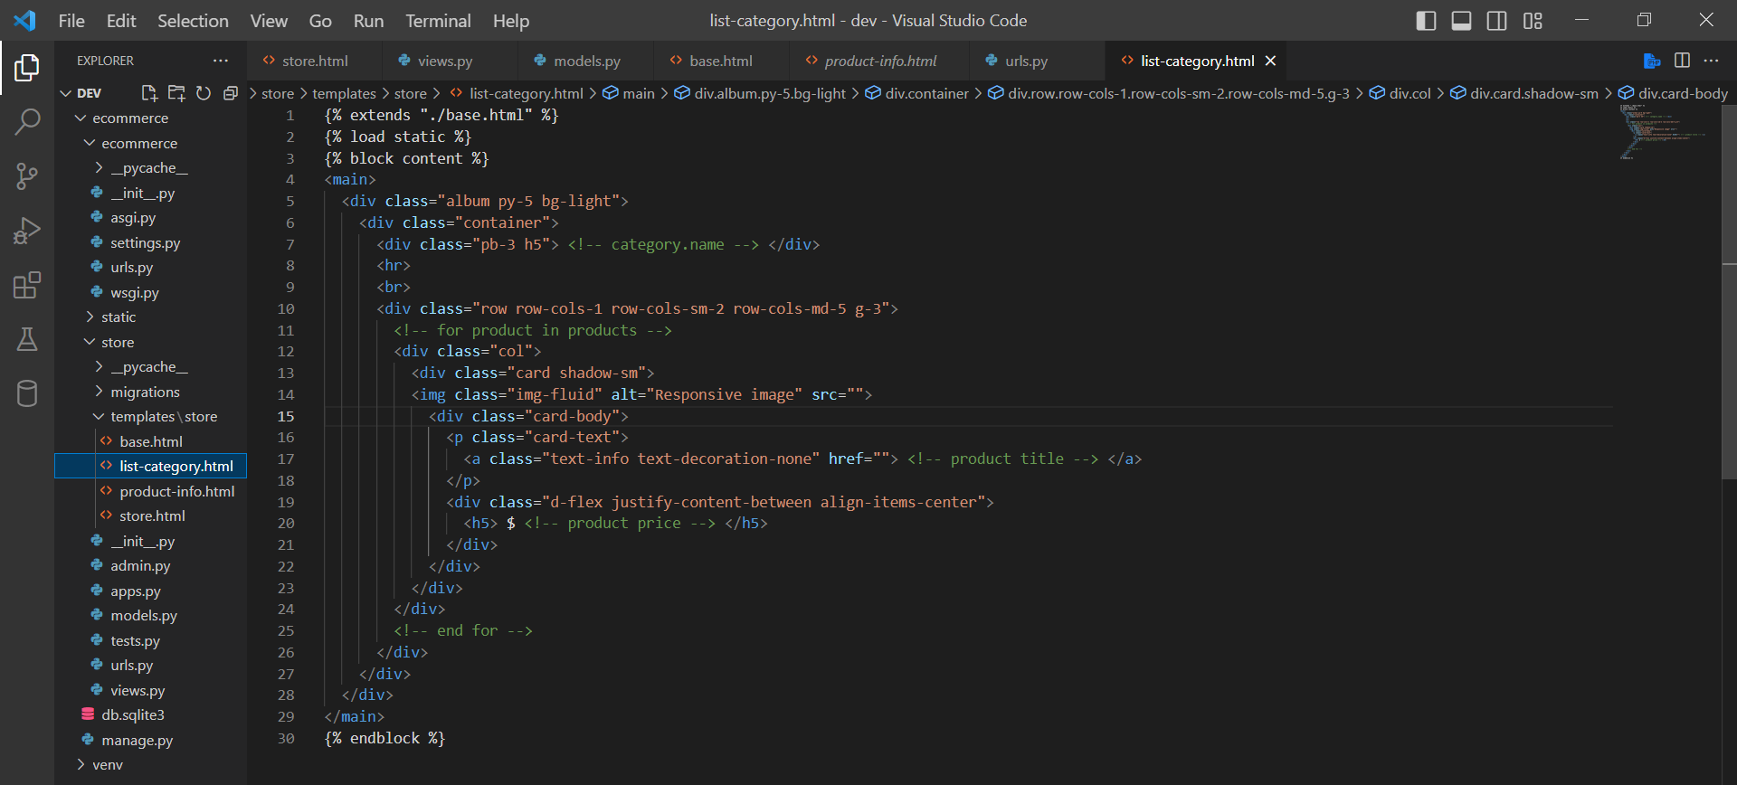

Add data to html

